**Part A.**

Repulsive Pressure = Prep =

Attraction Pressure = Patt =

Force due to Surface Tension = $\frac{4T}{r}$

For equilibrium: Total pressure of attraction = Total pressure of repulsion

Patt+ PT = Prep

)

for universe to be neither contracting nor expanding, the equation must have at least one positive real root, but from [Descartes’ rule of sign](https://en.wikipedia.org/wiki/Descartes%27_rule_of_signs) this equation can only have 2 or 0 positive roots, also if the equation have 2 positive roots (equal or distinct) then the total number of real roots must be 3 (cubic equations have odd number of real roots). Now let’s assume our equation have 3 real roots (only feasible solution).

Here the local minima is at r = $√\frac{k1}{12T}$ which is positive, thus the equation must have one positive roots (assuming as all roots are real).

**Thus we can say that if the equation have 3 real roots then 2 of them will be positive otherwise no positive root will exist**

Now, for 3 real roots (all coefficients are real) [discriminant of cubic](https://en.wikipedia.org/wiki/Discriminant) must be greater than or equal to zero (both positive roots are equal):

$-4\left(4T\right)\left( {-k}_{1}^{3}\right)-27{\left(4T\right)}^{2}{\left(k2\right)}^{2}≥0$

${T\left(k1\right)}^{3}-27{\left(T\right)}^{2} {\left(k2\right)}^{2}≥0$**,**

This is the necessary and sufficient condition for where at least One value of least one value of Radius(r) exists where the universe is neither expanding nor contracting.

**Part (B).**

Following set of constants have cardinal number of possible radii, rest have no such radii (rest have cardinal number zero) where universe is neither expanding nor contracting.

|  |  |  |  |  |
| --- | --- | --- | --- | --- |
| k1 | k2 | T | number of possible radii |  |
| 989 | 80 | 238 | 2 |  |
| 540 | 135 | 259 | 2 |  |
| 590 | 479 | 1 | 2 |  |
| 692 | 268 | 55 | 2 |  |
| 507 | 21 | 638 | 2 |  |
| 505 | 93 | 163 | 2 |  |

Here the number of possible radii are the positive roots of the force balance equation.

$$\frac{k_{2}}{r^{4}}+ \frac{4T}{r}= \frac{k_{1}}{r^{3}}$$

The solution is obtained from the following python script

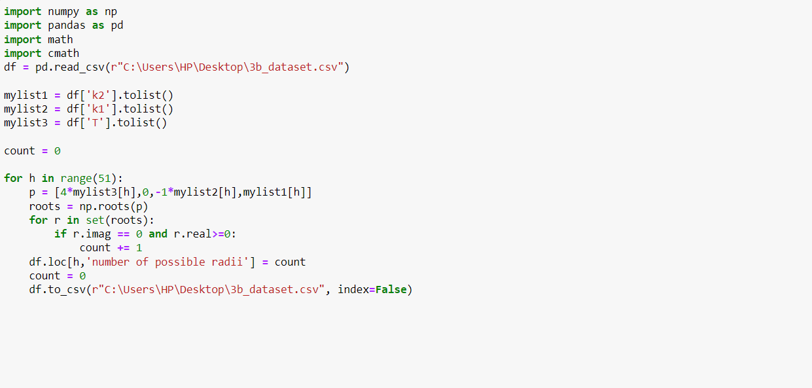Solution Dataset

<https://docs.google.com/spreadsheets/d/1HEowlKrUiX2U-04Vc0NW0YnVXVIKE253ID9AcRAQei8/edit?usp=sharing>

**part C.**

For given values of k1, k2, T and R all the systems are contracting.

Script used:

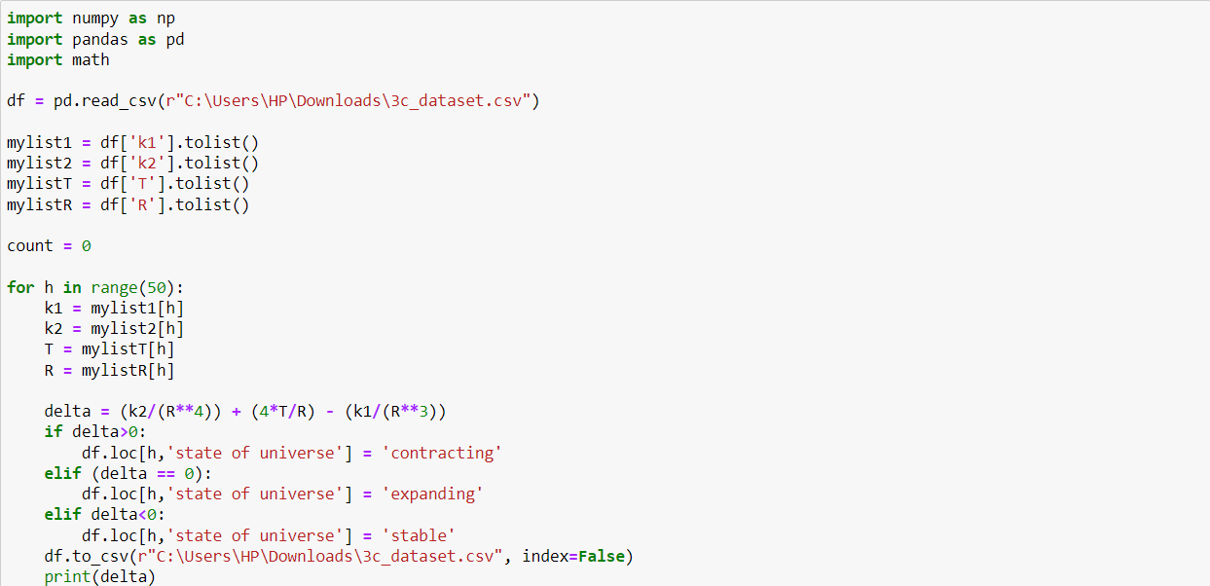solution dataset:

<https://drive.google.com/file/d/1_R7JL-sdjZ18NyJwX7xAk-XL6zEBl4oN/view?usp=sharing>

Following script is used to draw the graphs and mark the stable radii;

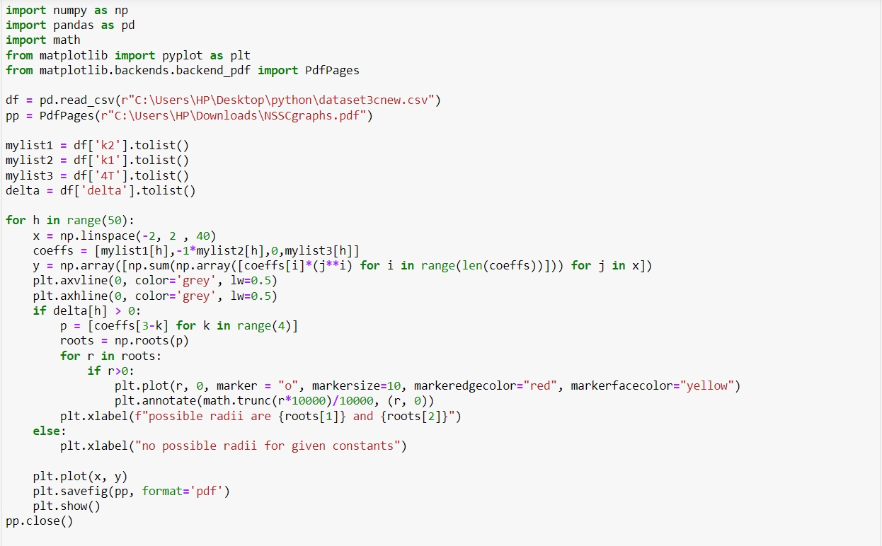

The generated graphs are:

<https://drive.google.com/file/d/1zLlckFueP9NIXANV-ID0I3tZodHFu33O/view?usp=sharing>